The HR department wants you to create SQL statements to insert, update, and delete employee data. As a prototype, you use the MY_EMPLOYEE table, prior to giving the statements to the HR department.
Insert data into the MY_EMPLOYEE table.
- Describe the structure of the MY_EMPLOYEE table to identify the column names.
Describe MY_EMPLOYEE
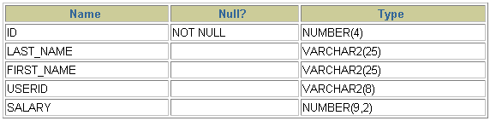
- Create an INSERT statement to add the first row of data to the MY_EMPLOYEE table from the following sample data. Do not list the columns in the INSERT clause. Do not enter all rows yet.
INSERT INTO MY_EMPLOYEE VALUES(1,‘Patel’,’Ralph’,’rapatel’,895);
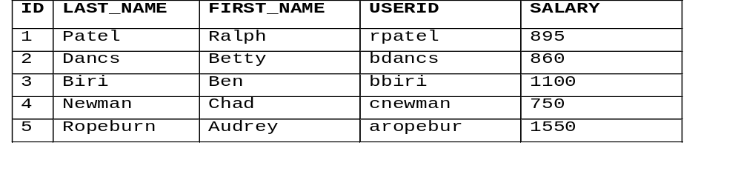

- Populate the MY_EMPLOYEE table with the second row of sample data from the preceding list. This time, list the columns explicitly in the INSERT clause.
INSERT INTO MY_EMPLOYEE(ID,LAST_NAME,FIRST_NAME,USERID,SALARY)
VALUES(2,’Dancs’,’Betty’,’bdancs’,860);
- Confirm your addition to the table.
SELECT*FROM MY_EMPLOYEE
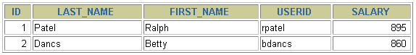
- Populate the table with the next two rows of sample data by running the insert
INSERT INTO MY_EMPLOYEE VALUES(3,‘Beri’,’Ben’,’bbiri’,1100);
INSERT INTO MY_EMPLOYEE VALUES(4,‘Newman’,’Chad’,’cnewman’,750);

- Confirm your additions to the table.
Select*from MY_EMPLOYEES
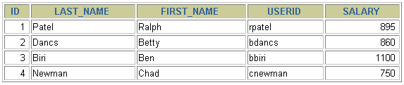
- Make the data additions permanent.
COMMIT;
Update and delete data in the MY_EMPLOYEE table.
- Change the last name of employee 3 to Drexler.
SET LAST_NAME=’Drexler’
WHERE ID=3;
- Change the salary to $1,000 for all employees who have a salary less than $900.
SET SALARY=1000
WHERE SALARY<900;
- Verify your changes to the table.
SELECT*FROM MY_EMPLOYEES
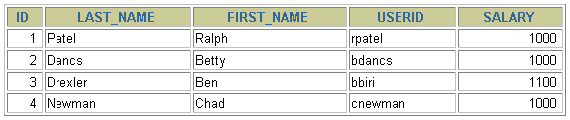
- Delete Betty Dancs from the MY_EMPLOYEE table.
DELETE FROM MY_EMPLOYEE
WHERE ID=2;
- Confirm your changes to the table.
SELECT*FROM MY_EMPLOYEE
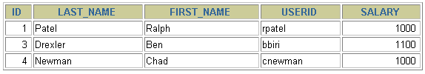
- Commit all pending changes.
COMMIT;
Control data transaction to the MY_EMPLOYEE table.
- Confirm your addition to the table.
SELECT*FROM MY_EMPLOYEE
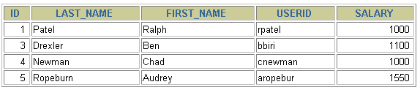
- Mark an intermediate point in the processing of the transaction.
SAVE POINT A;
- Empty the entire table.
DELETE FROM MY_EMPLOYEE;
- Confirm that the table is empty.
SELECT *FROM MY_EMPLOYEE
- Discard the most recent DELETE operation without discarding the earlier INSERT operation.
ROLLBACK TO A;
- Confirm that the new row is still intact.
SELECT*FROM MY_EMPLOYEE
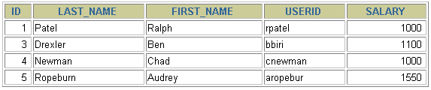
- Make the data addition permanent.
COMMIT;

